Отчет о проделанной лабораторной работе№10

Формула Тейлора для функций одной переменной

выполнила Марина А. группа ПИН-14

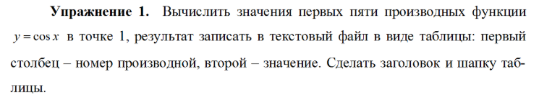

%task 1

x0=1

[F,mes]=fopen('Pract10_1.txt', 'w');

fprintf(F, 'ТАБЛИЦА ПЕРВЫХ 5ТИ ПРОИЗВОДНЫХ ФУНКЦИИ Y=COS(X)\r\n');

fprintf(F,'___________________________________________\r\n');

fprintf(F,'|номер производной|значение|\r\n');

fprintf(F,'_____________________________________________\r\n');

syms x;

f=cos(x);

f=diff(f);

x=subs(f,1);

fprintf(F,'|1|%7.5f|\r\n',x);

f=diff(f);

x=subs(f,1);

fprintf(F,'|2|%7.5f|\r\n',x);

f=diff(f);

x=subs(f,1);

fprintf(F,'|3|%7.5f|\r\n',x);

f=diff(f);

x=subs(f,1);

fprintf(F,'|4|%7.5f|\r\n',x);

f=diff(f);

x=subs(f,1);

fprintf(F,'|5|%7.5f|\r\n',x);

fclose(F);

ТАБЛИЦА ПЕРВЫХ 5ТИ ПРОИЗВОДНЫХ ФУНКЦИИ Y=COS(X)

___________________________________________

|номер производной|значение|

_____________________________________________

|1|-0.84147|

|2|-0.54030|

|3|0.84147|

|4|0.54030|

|5|-0.84147|

…………………………………………………………………………………………………………………………………………..

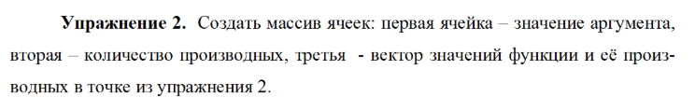

>> m{1,1}=1;

>> m{1,2}=5;

>> m{1,3}=[-0.8415, -0.5403,0.8415,0.5403,-0.8415];

>> cellplot(m)



……………………………………………………………………………………………………………………………………………..

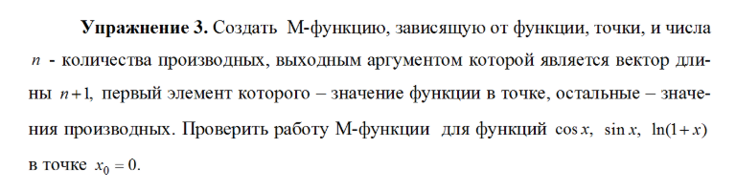

М-функция:

function p=fun(y,x0,n)

syms x;

b=subs(y,'x',x0);

for a=1:1:n

d=subs(diff(y,x,a),'x',x0);

b=[b,d];

end

p=b;

Command window

>> fun(cos(x),0,5)

ans =

1 0 -1 0 1 0

>> fun(sin(x),0,5)

ans =

0 1 0 -1 0 1

>> fun(log(1+x),0,5)

ans =

0 1 -1 2 -6 24

……………………………………………………………………………………………………………………………………….

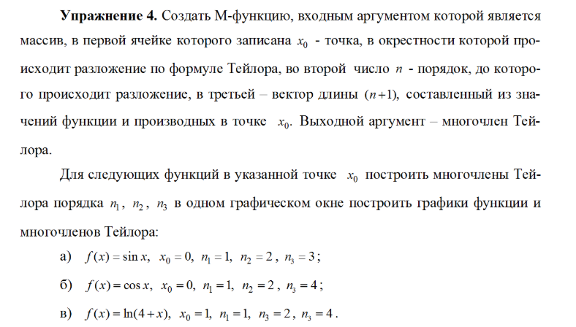

function t=pos(m)

syms x;

y=m{1,3}(1,1);

x0=m{1,1};

n=m{1,2};

for a=1:1:n

y=y+m{1,3}(1,a+1)*(x-x0)^a;

end

t=y;

***а)***

x0=0;

y=sin(x);

subs(y,'x',x0),

subs(diff(y,x,1),'x',x0),

subs(diff(y,x,2),'x',x0),

subs(diff(y,x,3),'x',x0),

ans = 0

ans = 1

ans = 0

ans = -1

m{1,1}=0;

m{1,2}=3;

m{1,3}=[0,1,0,-1];

>> pos(m)

ans =

x - x^3

ezplot('sin(x)'), hold on; ezplot('x'), ezplot('x'), ezplot('x-x^3'), axis([-2*pi 2*pi -1.5 1.5])

grid on



***Б)***

x0=0;

y=cos(x);

subs(y,'x',x0),

subs(diff(y,x,1),'x',x0),

subs(diff(y,x,2),'x',x0),

subs(diff(y,x,3),'x',x0),

subs(diff(y,x,4),'x',x0),

ans = 1

ans = 0

ans = -1

ans = 0

ans = 1

m{1,1}=0;

m{1,2}=4;

m{1,3}=[1,0,-1,0,1];

>> pos(m)

ans =

x^4 - x^2 + 1

>> ezplot('cos(x)'), hold on; ezplot('1'), ezplot('- x^2 + 1'), ezplot('x^4 - x^2 + 1'), axis([-2*pi 2*pi -1.5 1.5]);

grid on;



***В)***

>> x0=1;

y=log(4+x);

subs(y,'x',x0),

subs(diff(y,x,1),'x',x0),

subs(diff(y,x,2),'x',x0),

subs(diff(y,x,3),'x',x0),

subs(diff(y,x,4),'x',x0),

ans = 1.6094

ans = 0.2000

ans = -0.0400

ans = 0.0160

ans = -0.0096

>> m{1,1}=1;

m{1,2}=4;

m{1,3}=[1.6094, 0.2000, -0.0400, 0.0160, -0.0096];

>> pos(m)

ans =

x/5 - (x - 1)^2/25 + (2*(x - 1)^3)/125 - (6*(x - 1)^4)/625 + 7047/5000

>> ezplot('log(4+x)'), hold on; ezplot('7047/5000 + x/5'), ezplot('7047/5000 + x/5 - (x - 1)^2/25'),

ezplot('7047/5000 + x/5 - (x - 1)^2/25 + (2*(x - 1)^3)/125 - (6*(x - 1)^4)/625'), axis([-5 6 -1 5]); grid on;



……………………………………………………………………………………………………………………………………………….

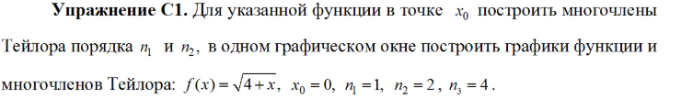

x0=0;

y=sqrt(4+x);

subs(y,'x',x0),

subs(diff(y,x,1),'x',x0),

subs(diff(y,x,2),'x',x0),

subs(diff(y,x,3),'x',x0),

subs(diff(y,x,4),'x',x0),

ans = 2

ans = 0.2500

ans = -0.0313

ans = 0.0117

ans = -0.0073

m{1,1}=0;

m{1,2}=4;

m{1,3}=[2, 0.2500, -0.0313, 0.0117, -0.0073];

>> pos(m)

ans =

- (73*x^4)/10000 + (117*x^3)/10000 - (313*x^2)/10000 + x/4 + 2

>> ezplot('sqrt(4+x)')

hold on

ezplot('2 + x/4')

ezplot('2 + x/4 - (313*x^2)/10000')

axis([-5 6 -1 5])

grid on;



…………………………………………………………………………….

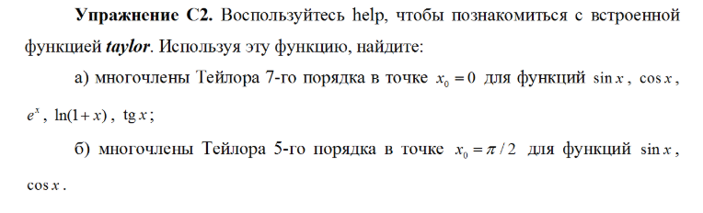

А)

>> taylor(sin(x),7,x,0)

ans =

x^5/120 - x^3/6 + x

>> taylor(cos(x),7,x,0)

ans = - x^6/720 + x^4/24 - x^2/2 + 1

>> taylor(exp(x),7,x,0),

ans = x^6/720 + x^5/120 + x^4/24 + x^3/6 + x^2/2 + x + 1

>> taylor(log(1+x),7,x,0),

ans = - x^6/6 + x^5/5 - x^4/4 + x^3/3 - x^2/2 + x

>> taylor(tan(x),7,x,0),

ans = (2*x^5)/15 + x^3/3 + x

б)

>> taylor(sin(x),5,x,pi/2),

ans = (pi/2 - x)^4/24 - (pi/2 - x)^2/2 + 1

>> taylor(cos(x),5,x,pi/2),

ans = pi/2 - x - (pi/2 - x)^3/6